# Image Microservice

A set of microservices to store, host and manipulate image files using a rest api

## Architecture

Services:

1. image-storage - Stores uploaded images and serves them back to the consumer
2. image-storage-db - A postgres container to store image metadata
3. image-transform - Takes a uploaded image, url or image_id for above service and transforms the iamge according to the passed parameters
4. nginx - An API layer which fronts all other microservices

Each service is contained within it's own docker container and can be built with the Dockerfiles. The full service can be builts and run with the docker-compose.yml file.

## Usage

### Image Storage/Retrieval

* GET: /image/healthcheck - will return status of sevice
* POST: /image with a form data key = 'Image' and Value as the file - will return a json response with the image_id
* GET: /image/{image_id} - will return the image in orginal format
* GET: /image/{image_id}.ext - will return the image converted into the file format defined by ext

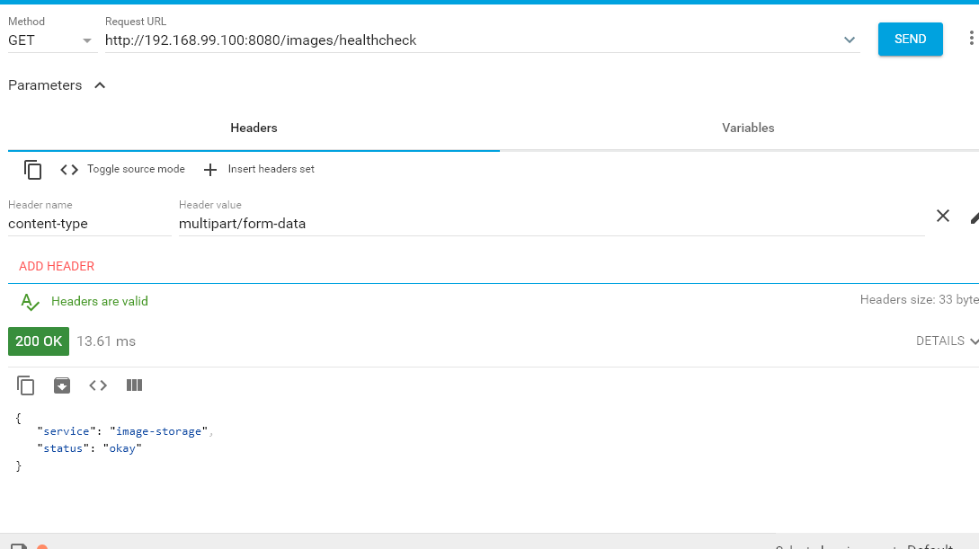

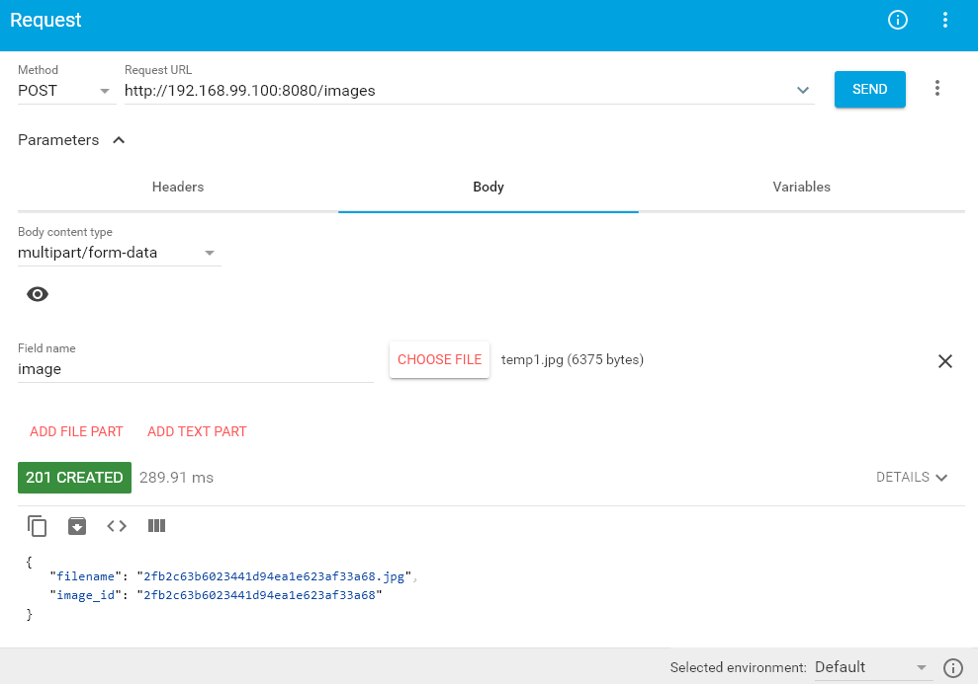

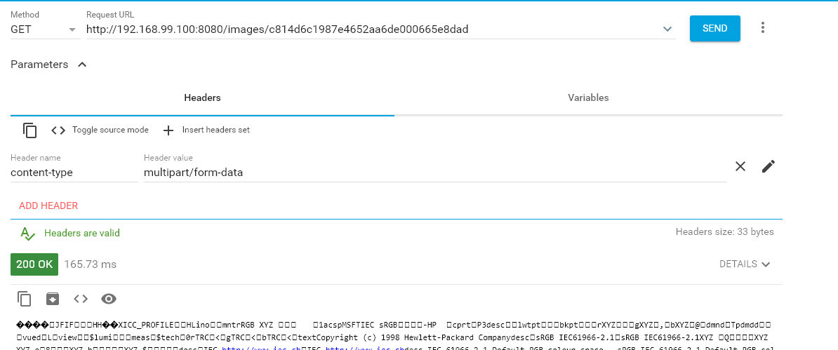

### Image Transformation

* POST: /transform?query_string with form data key = 'Image' and Value as a file - will return a tranformed file according to the query string.

Query String can contain a chained set of transformation from the following list:

* rotate={degrees}
* thumb={height_and_width}
* blur={radius_pixels}
* compress={0-100 where 100 is maximum quality}

And example is /trasnform?rotate=90&blur=10

